wazuh.
The Open Source Security Platform

Complete Project Walkthrough & Notes

Project | Detail
Reporter | Yash Paghada
Platform | Wazuh v4.12 (Server) + v4.14.5 (Agent)
Server | Ubuntu 26.04 LTS — IP: 192.168.1.24
Agent | Windows 11 Pro — WindowsAgent (ID: 001)
Date | June 15, 2026
Features Covered | Installation, FIM, Auth Monitoring, Vulnerability Detection

Security Information & Event Management (SIEM)

What is Wazuh?
Wazuh is a free, open-source security platform that provides unified protection across endpoints and cloud workloads. It combines Security Information and Event Management (SIEM) with Extended Detection and Response (XDR) capabilities.

Feature | Description
SIEM | Security Information & Event Management — collects and analyzes security logs from all connected machines in real time
XDR | Extended Detection & Response — detects threats across endpoints, networks and cloud
FIM | File Integrity Monitoring — detects any file changes (added, modified, deleted)
Vulnerability Detection | Scans agents for known CVEs and software vulnerabilities
Authentication Monitoring | Tracks login successes, failures and brute force attempts
Agent-Server Model | Central Wazuh server collects data from agents installed on monitored machines

Component | Role
Wazuh Server | Central brain — receives, analyzes and stores all security data
Wazuh Indexer | Stores and indexes all security events (based on OpenSearch)
Wazuh Dashboard | Web UI at https://192.168.1.24 — visualizes all alerts and data
Wazuh Agent | Installed on monitored machines — sends logs/events to the server

Phase 1: Wazuh Server Installation
The Wazuh server is installed on an Ubuntu 26.04 LTS machine. We use SSH to connect to it from Kali Linux and run the official Wazuh installation script which automatically installs all required components.

Step 1.1 — Connect to Ubuntu Server via SSH
Step 1: SSH into Ubuntu Server
Command:
ssh kali@192.168.1.24
Why:
We use SSH (Secure Shell) to remotely connect to our Ubuntu server from Kali Linux. 192.168.1.24 is the IP address of the Ubuntu machine where Wazuh will be installed. SSH provides an encrypted connection so all commands are sent securely.

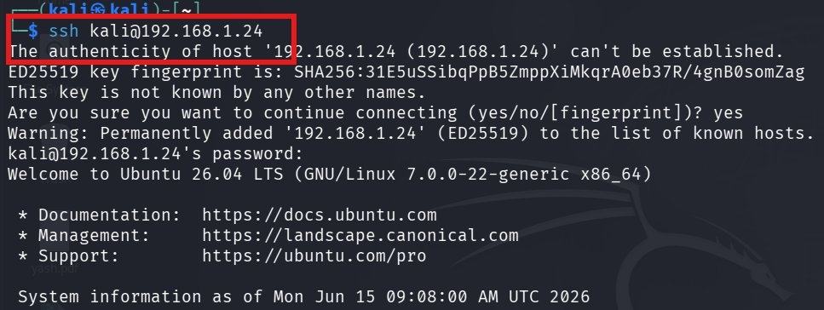

Server Details | Ubuntu 26.04 LTS | IP: 192.168.1.24 | Linux 7.0.0-22-generic x86_64

Step 1.2 — Add Wazuh GPG Key
Step 2: Import Wazuh GPG Key
Command:
curl -s https://packages.wazuh.com/key/GPG-KEY-WAZUH | sudo gpg --dearmor -o /usr/share/keyrings/wazuh-archive-keyring.gpg
Why:
A GPG (GNU Privacy Guard) key is used to verify that the Wazuh packages we download are authentic and haven't been tampered with. curl downloads the key and gpg --dearmor converts it to a format Ubuntu can use. This is a security best practice before installing any third-party software.

Step 1.3 — Run Wazuh Installation Script
Step 3: Download and Run Installation Script
Command:
curl -sO https://packages.wazuh.com/4.12/wazuh-install.sh && sudo bash ./wazuh-install.sh -a -i
Why:
The official Wazuh installation script (-a flag) automatically installs ALL components: Wazuh Server, Wazuh Indexer, and Wazuh Dashboard. The -i flag ignores hardware requirement warnings. The script handles all dependencies, configuration, and service startup automatically. Wazuh web interface will run on port 443 (HTTPS).

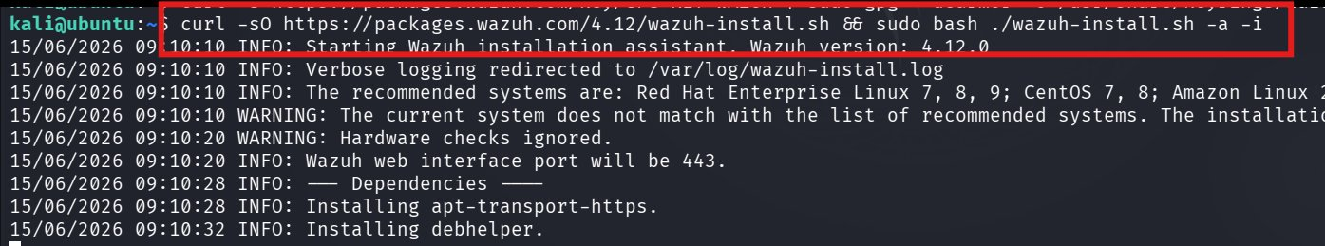

Flag | Meaning
-a | Install all components (server + indexer + dashboard)
-i | Ignore hardware compatibility warnings
Port 443 | Wazuh dashboard accessible via HTTPS
Version | Wazuh 4.12.0 installed

Step 1.4 — Access Wazuh Dashboard
After installation completes, open a browser and navigate to https://192.168.1.24. The Wazuh login page appears. Default credentials are provided at the end of the installation script output.
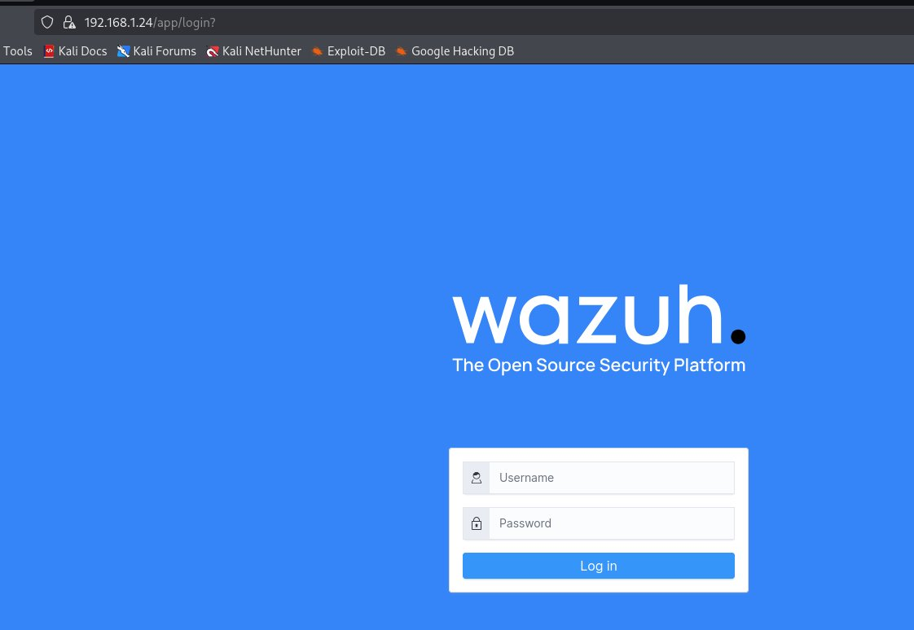

Dashboard URL | https://192.168.1.24/app/login | Default User: admin

Phase 2: Windows Agent Setup
A Wazuh agent is a lightweight software installed on machines we want to monitor. It collects security data (logs, file changes, network activity) and sends it to the Wazuh server in real time. We install the agent on a Windows 11 machine.

Step 2.1 — Download Windows Agent
On the Windows machine, open the official Wazuh documentation to download the Windows agent installer.
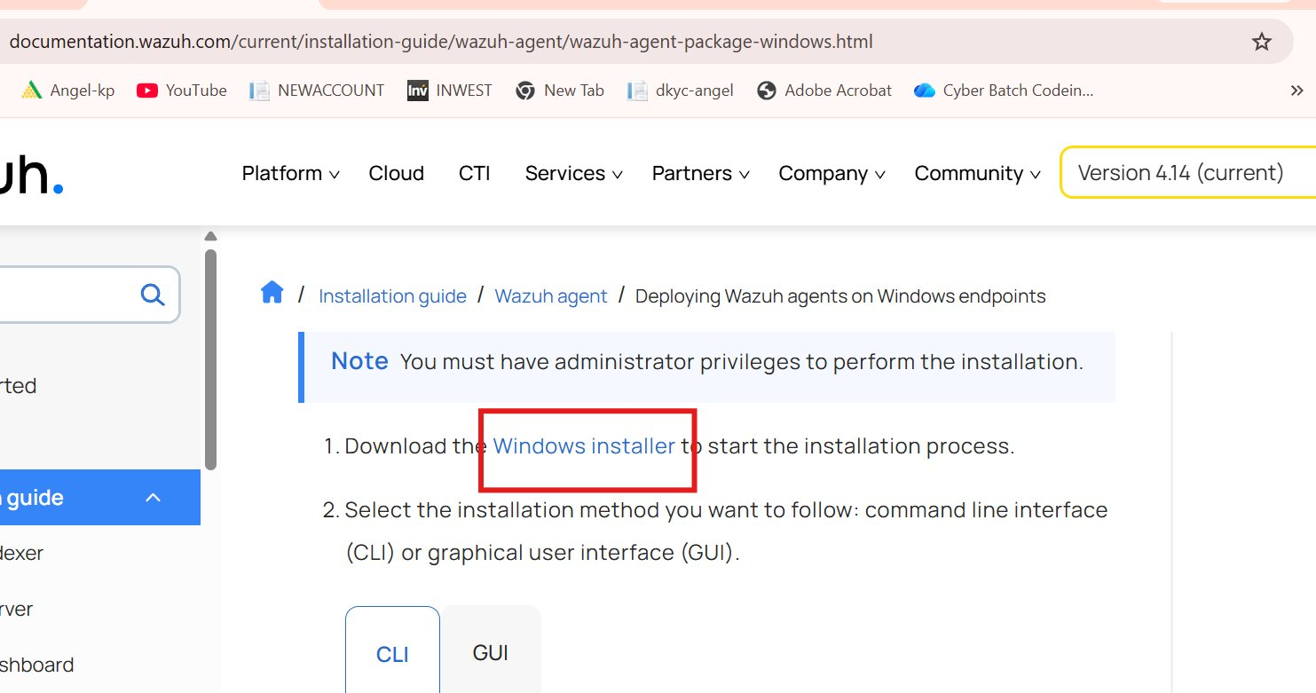

Documentation URL | documentation.wazuh.com/current/installation-guide/wazuh-agent/wazuh-agent-package-windows.html

Step 2.2 — Add Agent on Server (manage_agents)
Step 4: Open Agent Manager on Wazuh Server
Command:
sudo /var/ossec/bin/manage_agents
Why:
manage_agents is the Wazuh command-line tool for managing agents. It runs on the Wazuh SERVER and lets us add, remove, list agents and extract authentication keys. We choose option A to add a new agent.

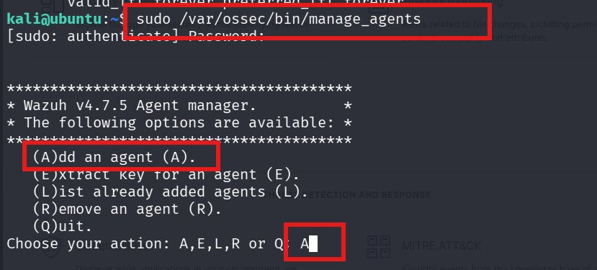

Step 2.3 — Name the Agent
When prompted, we give the agent a descriptive name 'WindowsAgent' and provide the IP address of the Windows machine.
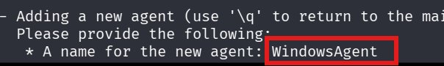

Step 2.4 — Confirm and Extract Agent Key
After confirming, the agent is registered with ID 001. We then choose option E to extract the authentication key that will be used to connect the Windows agent to the server.
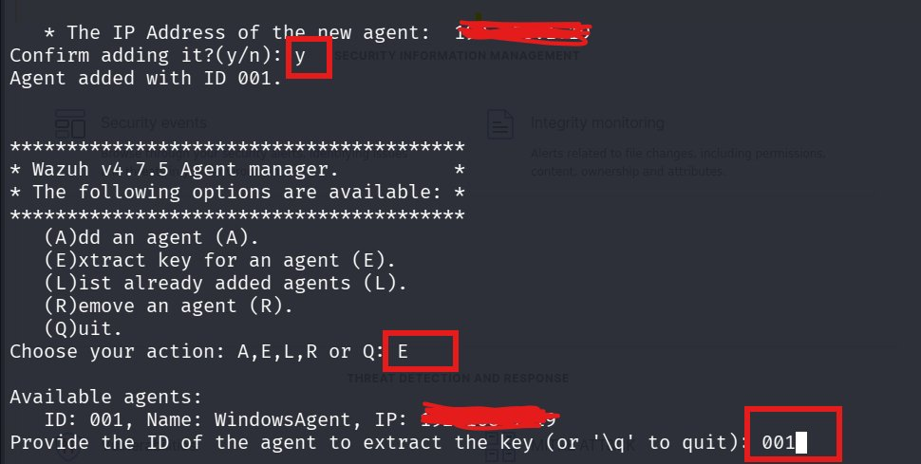

The agent key is a long Base64-encoded string that uniquely identifies and authenticates the agent to the server. This key must be imported on the Windows machine.

Agent Detail | Value
Agent Name | WindowsAgent
Agent ID | 001
Manager IP | 192.168.1.24
Authentication | Long Base64 key extracted with option E

Step 2.5 — Configure Windows Agent GUI
On the Windows machine, open the Wazuh Agent GUI. Enter the Manager IP (192.168.1.24) and paste the authentication key extracted from the server. Save and restart the agent service.
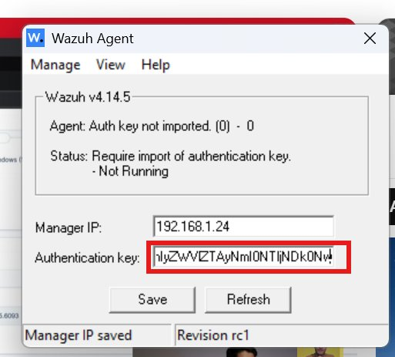

Field | Value
Manager IP | 192.168.1.24
Authentication Key | Paste key from manage_agents step E
Status Before | Auth key not imported — Not Running
Status After | Connected and Running

Phase 3: File Integrity Monitoring (FIM)
File Integrity Monitoring (FIM) is one of Wazuh's most powerful features. It monitors specified directories for ANY changes — files being added, modified, or deleted — and sends real-time alerts to the dashboard. This is critical for detecting unauthorized changes to important files.

FIM Concept | Explanation
What it does | Monitors files and directories for changes in real time
Why important | Detects malware dropping files, unauthorized modifications, data theft
How it works | Agent calculates file checksums and reports any changes to server
Alert levels | Level 5 = file added, Level 7 = file deleted, Level 6 = file modified

Step 3.1 — Configure FIM in ossec.conf
The ossec.conf file is the main configuration file for the Wazuh agent on Windows. It is located at:
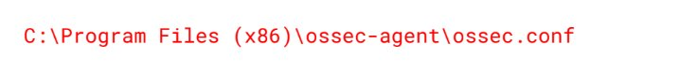

We edit this file to add a directory we want to monitor in real time. The realtime="yes" attribute means changes are detected immediately, not just at scheduled scan times.
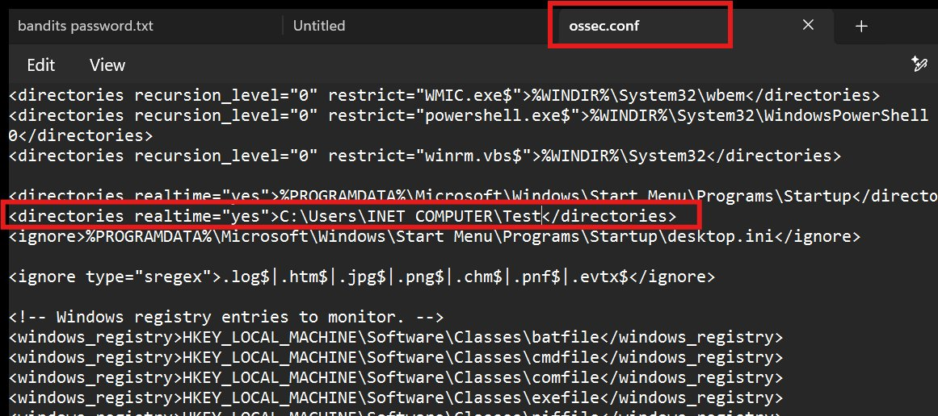

<directories realtime="yes">C:\Users\INET COMPUTER\Test</directories>
This line tells the Wazuh agent to monitor C:\Users\INET COMPUTER\Test in real time and report any file changes immediately to the server.

Step 3.2 — Create Test Files in Monitored Folder
We create a test folder C:\Users\INET COMPUTER\Test and add a file called 'yash.txt' inside it to trigger FIM alerts.
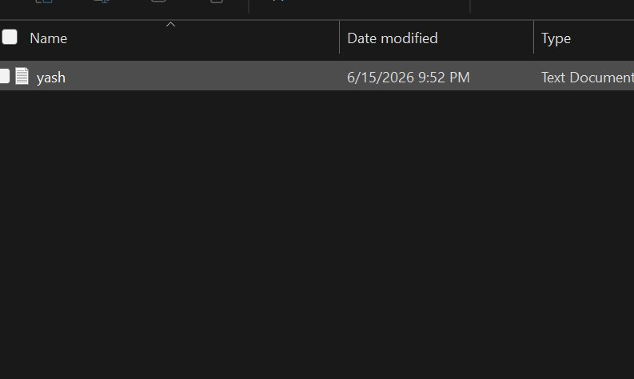

Step 3.3 — View FIM Alerts on Dashboard
The Wazuh dashboard immediately shows FIM events. Every time a file is added, renamed, or deleted inside the monitored folder, an alert is generated with the file path, action type, and alert level.
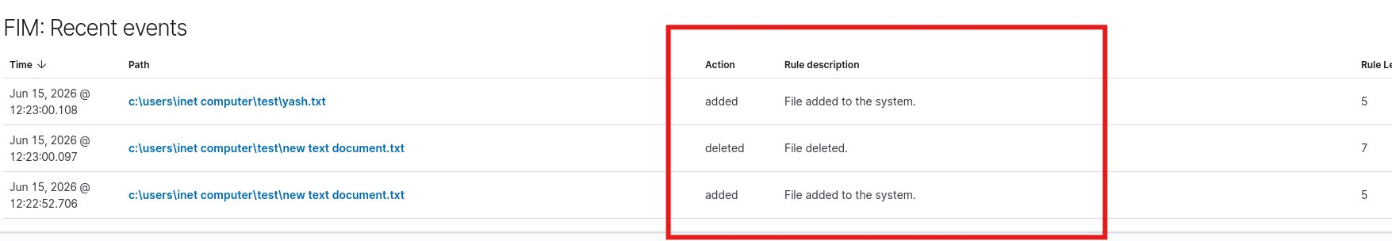

FIM Event | Details
File Added | c:\users\inet computer\test\yash.txt — Level 5 — File added to the system
File Added | c:\users\inet computer\test\new text document.txt — Level 5
File Deleted | c:\users\inet computer\test\new text document.txt — Level 7 — File deleted
Detection | Real-time — alerts appeared within seconds of file operations

Phase 4: Authentication Monitoring
Wazuh automatically monitors all authentication events on connected agents — successful logins, failed login attempts, account lockouts, and privilege escalations. This is critical for detecting brute force attacks and unauthorized access attempts.

Step 4.1 — Simulate Failed Login Attempt
We press Win+L to lock the Windows screen, then deliberately enter wrong passwords to simulate a brute force or unauthorized login attempt.
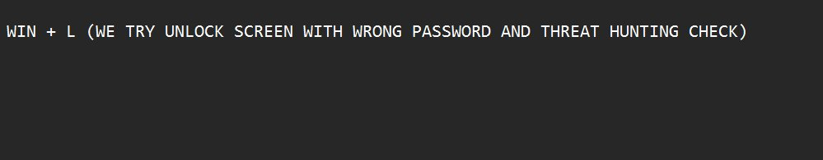

Every wrong password attempt on Windows generates a Windows Security Event Log entry (Event ID 4625 — Failed Logon). Wazuh agent captures these events and forwards them to the server which triggers authentication failure alerts.

Step 4.2 — View Authentication Dashboard
The Wazuh dashboard shows a clear summary of all authentication events for the Windows agent (ID: 001) over the last 24 hours.
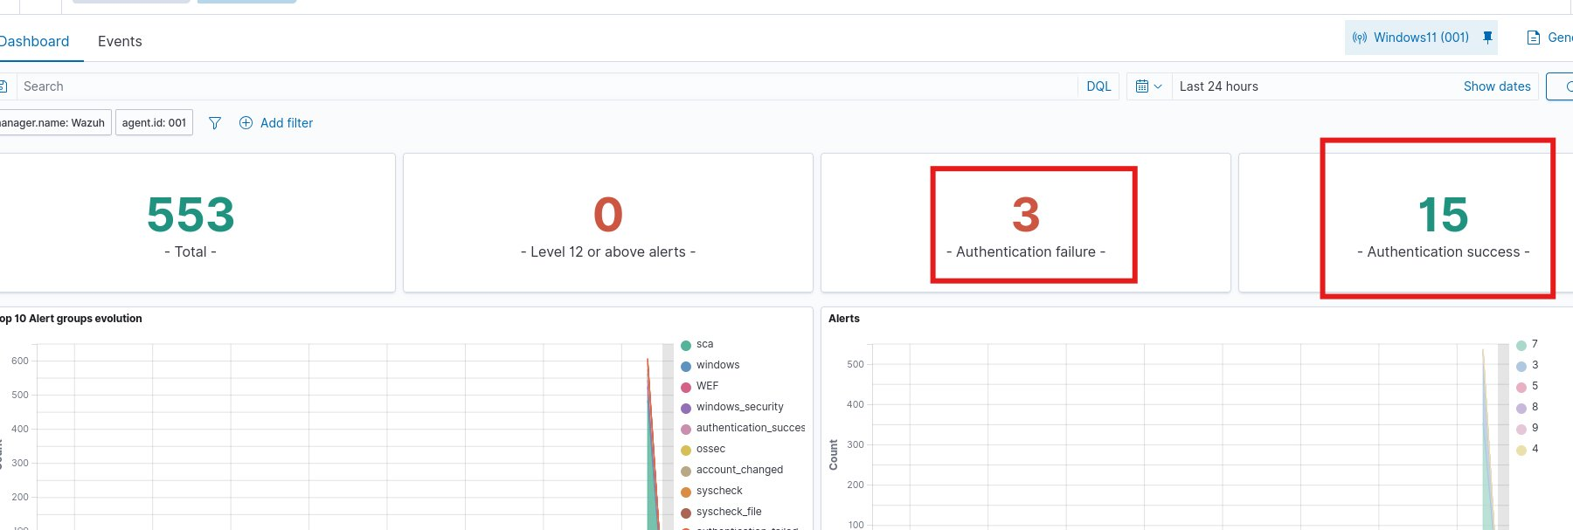

Metric | Value
Total Events | 553 security events in 24 hours
Level 12+ Alerts | 0 critical alerts
Authentication Failures | 3 failed login attempts detected
Authentication Success | 15 successful logins recorded
Alert Groups | windows, WEF, windows_security, authentication_success, syscheck

Windows Event ID | Meaning
4625 | Failed logon attempt — triggers authentication failure alert
4624 | Successful logon — recorded as authentication success
4740 | Account locked out — high severity alert
4648 | Logon using explicit credentials

Phase 5: Vulnerability Detection
Wazuh's Vulnerability Detection module scans all software installed on connected agents and compares it against the National Vulnerability Database (NVD) and other CVE databases. It identifies known security vulnerabilities in installed applications and rates them by severity.

Concept | Explanation
CVE | Common Vulnerabilities and Exposures — unique identifier for known security flaws
NVD | National Vulnerability Database — official US government CVE database
Severity | Critical / High / Medium / Low — based on CVSS score
CVSS Score | Common Vulnerability Scoring System — 0-10 scale rating vulnerability severity

Step 5.1 — Navigate to Vulnerability Detection
In the Wazuh dashboard, go to Threat Intelligence → Vulnerability Detection to see the vulnerability scan results for all connected agents.
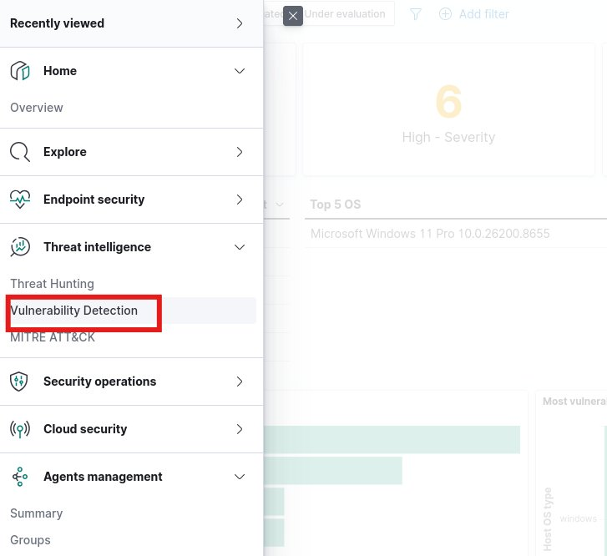

Step 5.2 — View Vulnerability Scan Results
Wazuh automatically scanned the Windows 11 agent and found multiple vulnerabilities in installed software. The results are categorized by severity level.
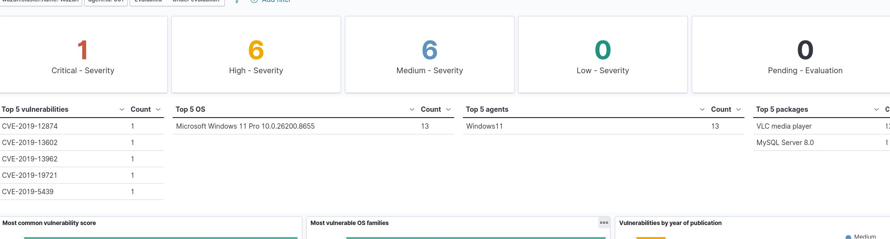

Severity | Count
Critical | 1 — Immediate action required
High | 6 — Should be patched soon
Medium | 6 — Monitor and plan remediation
Low | 0
Total CVEs Found | 13 vulnerabilities on Windows11 agent

Top CVEs Found | Details
CVE-2019-12874 | Found in installed software on Windows 11
CVE-2019-13602 | Found in installed software on Windows 11
CVE-2019-13962 | Found in installed software on Windows 11
CVE-2019-19721 | Found in installed software on Windows 11
CVE-2019-5439 | Found in installed software on Windows 11
Vulnerable Package 1 | VLC Media Player — multiple CVEs detected
Vulnerable Package 2 | MySQL Server 8.0 — CVEs detected
OS Scanned | Microsoft Windows 11 Pro 10.0.26200.8655

Project Summary
This project demonstrated a complete Wazuh SIEM deployment from installation to active monitoring. The setup successfully detected and alerted on multiple security scenarios in real time.

Phase | What We Did
Phase 1 — Installation | Installed Wazuh server on Ubuntu 26.04 via official script — Dashboard at https://192.168.1.24
Phase 2 — Agent Setup | Registered Windows 11 agent (ID: 001) using manage_agents and imported auth key via GUI
Phase 3 — FIM | Configured real-time file monitoring on C:\Users\INET COMPUTER\Test — detected file add/delete instantly
Phase 4 — Auth Monitoring | Simulated failed logins via Win+L — Wazuh detected 3 failures and 15 successes in 24h
Phase 5 — Vuln Detection | Automated scan found 13 CVEs — 1 Critical, 6 High in VLC and MySQL

Tool / Command | Purpose
ssh kali@192.168.1.24 | Remote access to Ubuntu server from Kali
curl + gpg --dearmor | Add Wazuh GPG key for package verification
wazuh-install.sh -a -i | Full automatic installation of all Wazuh components
manage_agents | Add/list/remove agents and extract auth keys on server
ossec.conf | Agent configuration file — add FIM directories here
realtime="yes" | Enable instant file change detection (not scheduled)
Wazuh Dashboard | Web UI at port 443 — view all alerts, events, vulnerabilities

Key Concept | Explanation
SIEM | Centralized security monitoring — all events from all machines in one place
Agent-Server Model | Agents collect data, server analyzes and stores — scalable architecture
FIM | Any file change in monitored directory triggers instant alert
Auth Monitoring | Every login success/failure logged — detect brute force automatically
Vulnerability Detection | Compares installed software against CVE databases automatically
ossec.conf | Main config file — controls what the agent monitors and reports

Wazuh Restart Guide
Run these steps every time you restart your laptop

Step 1: Start Wazuh Services on Ubuntu
Start all services:
sudo systemctl start wazuh-manager wazuh-indexer wazuh-dashboard
Check service status:
sudo systemctl status wazuh-manager wazuh-indexer wazuh-dashboard
Expected Output:
active (running)

Step 2: Verify Connected Agents on Ubuntu
Run on Ubuntu server:
sudo /var/ossec/bin/agent_control -l
Note: This is the LAST step on Ubuntu — run AFTER starting Windows agent with correct IP and key.
Expected Output:
ID: 000 Wazuh Active
ID: 001 Windows11 Active

Step 3: Start Windows Agent (on Windows Machine)
Open Command Prompt as Administrator and run:
sc start WazuhSvc
Verify Agent Status:
sc query WazuhSvc
Expected Output:
STATE : 4 RUNNING

Step 4: Access Wazuh Dashboard
Open browser and navigate to:
https://192.168.1.24
Login Credentials:
Username: admin Password: (your password from installation)

Step 5: Verify Agent Status in Dashboard
Navigate to:
Dashboard → Agents Management → Summary
Expected:
Windows11 → Active (green)

Quick Restart Checklist
# | Task | Where
1 | SSH into Ubuntu: ssh kali@192.168.1.24 | Kali Linux terminal
2 | Start services: sudo systemctl start wazuh-manager wazuh-indexer wazuh-dashboard | Ubuntu terminal
3 | Check status: sudo systemctl status wazuh-manager | Ubuntu terminal
4 | Start Windows agent: sc start WazuhSvc (as Admin) | Windows CMD (Admin)
5 | Verify agent: sc query WazuhSvc → STATE: RUNNING | Windows CMD (Admin)
6 | Verify agents: sudo /var/ossec/bin/agent_control -l | Ubuntu terminal
7 | Open dashboard: https://192.168.1.24 → login as admin | Any browser
8 | Check Agents → Windows11 shows Active (green) | Wazuh Dashboard

Project Features Demonstrated
- Centralized Log Management — all security events from Windows agent collected in one place
- Vulnerability Detection — automated CVE scanning found 1 Critical, 6 High vulnerabilities
- File Integrity Monitoring (FIM) — real-time detection of file add/modify/delete in monitored folders
- Security Event Monitoring — 553 security events captured and analyzed
- Failed Login Detection — 3 authentication failures detected from Win+L wrong password test
- Real-Time Alerting — instant alerts on dashboard for all security events
- Endpoint Monitoring — complete visibility into Windows 11 machine activity

Wazuh SIEM Project — Complete!
Server: 192.168.1.24 | Agent: Windows11 (001) | Status: Active & Monitoring

